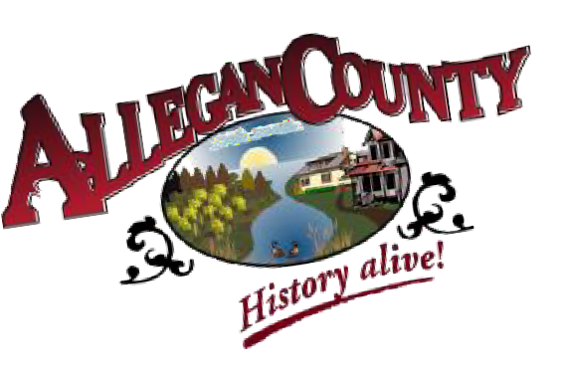
A l l e g a n C o u n t y T o u r i s t
C o u n c i l
Allegan County Parks, Recreation & Tourism
3283 122nd Ave
Allegan, MI 49010
269-686-9088
parks@allegancounty.org http://www.allegancounty.org

Chairperson: Jamie Krupka

Vice Chairperson: Chris Dulac

Maria Albright
269-686-6595
Allegan

Scott Beltman
616-292-1414
Hopkins

Rick Cain
269-774-7918
Shelbyville

Chris Dulac
269-673-4625
Allegan

Matt Helmus
616-355-1031
Holland

Jamie Krupka
616-886-5568
Holland

Debbie Laraway
269-416-0221
Pullman

Tim Perrigo
269-686-0276
Allegan
TOURIST COUNCIL MEETING – MINUTES
Tuesday, August 17, 2021 @ 10:00am
Zimmerman Room – Human Service Building – 3255 122nd Ave, Allegan, MI 49010

CALL TO ORDER: Meeting was called to order by Krupka at 10:10 am

ROLL CALL:
Members Present: Maria Albright, Rick Cain, Chris Dulac, Matthew Helmus, Tim Perrigo, Jamie Krupka
Members Absent: Rick Cain, Debbie Laraway
Also Present: Brandy Gildea, Heather Bausick

- Introductions were made with New member Scott Beltman. He wants to attract more people to the county and be more active within the community.

APPROVAL OF MINUTES: A motion was made by Helmus, seconded by Perrigo to approve the May 18, 2021 minutes as presented. The motion carried.

PUBLIC PARTICIPATION: None

APPROVAL OF AGENDA: A motion was made by Helmus, seconded by Albright to approve the agenda as presented. The motion carried.

ADDITIONAL AGENTA ITEMS: NONE

REVIEW ITEMS:
- Financial Statements - Gildea stated the financial reports are in the agenda packet and displayed on the monitor; to date very little money has been spent and most of the money is remaining. Money that has been spent has been on advertising and the phone line. Remaining expenditures will be WMTA Facebook posts and advertisement in the Fall Shoreline guide.

RECOMMENDATION/ACTION ITEMS:
1. None

DISCUSSION ITEMS:
1. Heritage Trail Project – Gildea recapped the information collected from the small group meeting on July 23rd between Helmus, Perrigo, Gildea, and Bausick including sites for deletion, additions, and drive-by sites. POW camp/CCC site was discussed as a potential wording dispute and all historical info needs to be accurate before posting/printing. Discussed breaking the trail up into segments. Also discussed new marketing tools for Heritage trail including a phone app, full sheet map, Z-cards and even a potential renaming of the trail itself. The name “Explore Allegan County” was suggested. More discussion on the name will occur at the next Tourist Council meeting. Next small group meeting for this trail is August 26th.

NOTICE OF APPOINTMENTS:
- Vacancy: term expires 12/23

FUTURE AGENDA ITEMS:
- Recreation trails/mapping/update website
- County is updating webpage – would like to link our websites to the county webpage instead of maintaining separate websites but will keep Heritage Trail separate
- Welcome signage for people coming into County

ROUND TABLE:

Dulac – Huntington Bank closing and moving to Chemical bank downtown location. Aubrees Pizza is now a Mexican restaurant. Courthouse construction continues. Parking lot redone behind Bubbas. Hotel will be a Hampton Inn and will break ground by the end of the month. Safe Harbor bought property behind bowling alley and building a new facility.

Perrigo – 4 ribbon cuttings and 10 more in the que-lots of new businesses opening. Allegan held food truck rally for 7 weeks. Rolling on the River brought in 200-300 people/week. Social district has been a hit. Timber Cannabis had a grand opening and Biggby will be opening.

Helmus – Has been a great season beating even their 2019 season. Not enough employees so may have to end the season early.

Albright – Game Area continues to be short staffed. Very busy with usage in the game area and they have had a dry spring so have been able to complete a lot of prescribed burning. Anterless deer permits are being restructured.

Beltman- He would like to see signage for people coming into county (add to future agenda). He would like to see more equestrian trails but Gildea stated due to low number of volunteers, the current trails can minimally be maintained. Cannot add more to the volunteers.

Krupka – ODC very busy. Personally he has purchased a food truck called Peachwave and it is going well. The ODC is opening another preschool this fall and a nature playscape is being built. Krupka announced his resignation from board due to time constraints. Ashley VanZee to be his replacement and she will fill out application and Krupka will submit his letter of resignation.

Gildea – Busy Season trying to keep up with parks. For example, Ely Lake in 2014/2015 season made $12,000-$15,000 for the year and so far this year for the 2020/2021 season, Ely Lake has brought in $49,000 so far and the year isn’t over yet.

Bausick – Agreed with Brandy. Very busy start to the year. Phone calls and requests for tourism literature has been extensive.

ADJOURNMENT: Next Meeting – Tuesday, November 16, 2021 @ 10:00 in Zimmerman Room (Human Service Building – 3255 122nd Ave, Allegan, MI 49010)
A motion was made by Dulac, seconded by Albright to adjourn the meeting at 11:30am. The motion carried.

